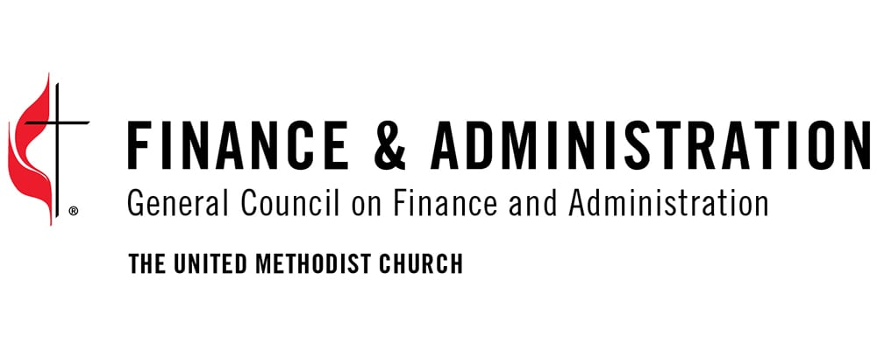

**General Council on Finance and Administration of the United Methodist Church  
Secretary/Chief Executive Officer**Nashville, TN

The Board of Directors of the General Council on Finance and Administration (GCFA) of the United Methodist Church (UMC) seeks a faithful, authentic, and forward-thinking leader to serve as the next General Secretary/Chief Executive Officer (GS/CEO). A non-profit agency serving the Church since the 1940’s, GCFA is a servant ministry of the Church, accountable for its financial plan and budgets, for its collection and distribution of revenues, and for protecting the legal rights and interests of the denomination. Within the highly decentralized structure of the UMC, GCFA serves as a linchpin, promoting fiscal integrity, strategic alliance building, and steadfast leadership, and thereby enabling the fulfillment of the mission and ministry of the UMC. In a time of continuing challenge for the UMC and other mainline Protestant denominations, the GS/CEO plays a critically important role in helping the denomination work through necessary change to achieve a sustainable future.

Reporting to the GCFA Board of Directors, the GS/CEO leads the organization and its staff in defining GCFA’s goals and in facilitating its effort to meet its Disciplinary and other responsibilities in a manner consistent with the mission and ministry of the UMC. The GS/CEO serves as Treasurer of the GCFA and as General Treasurer of the General Conference of the UMC. The GS/CEO also serves as an ex officio member of the Board of the United Methodist Insurance Program and the United Methodist Church Foundation Board (now InvestUMC). The GS/CEO works collaboratively with a wide range of connectional partners, including the Council of Bishops, General Secretaries and Board members of UMC agencies, and Treasurers of Annual Conferences, among many others. The GS/CEO oversees the executive leadership team and a total GCFA staff of 57.

The successful candidate will demonstrate strong leadership, a deep commitment to GCFA’s mission as both a ministry of the Church and a provider of financial, managerial, and investment services. The GS/CEO will bring a vision for GCFA as a trusted partner to its stakeholders, proven sound judgment, fiscal acumen in interpreting financial information and aligning budgets with strategic priorities, strong strategic skills in attaining challenging objectives, proven collaborative and relational skills, excellent communication skills, the ability to interact with constituents at all levels, and political astuteness and understanding of the intricacies of leadership in a denominational setting. Requirements include an advanced degree, and substantial experience in executive-level financial or administrative leadership within a multi-layered organization, preferably with some experience as the chief executive.

Given GCFA’s identity as a ministry of the UMC, it is required that the GS/CEO be an active member of a UMC congregation. For more information on the role, please see the full leadership profile on the DSG Global website <https://dsgco.com/search/22301-gcfa-general-secretary>

Screening will begin immediately and continue until an appointment is made. Completed applications should be submitted using DSG’s Talent Profile (<https://talent-profile.dsgco.com/search/v2/22301>) and should include a CV and a cover letter addressing (1) interest in position and (2) how the candidate’s experience will help GCFA achieve a sustainable future. Nominations and inquiries should be directed electronically to [GCFAGeneralSecretary@divsearch.com](mailto:GCFAGeneralSecretary@divsearch.com)

Kim M. Morrisson, Ph.D, and Euris E. Belle, Senior Advisors  
Christine Falcone, Senior Associate  
DSG|Global  
One Commerce Square, 2005 Market Street, Suite 3300, Philadelphia PA 19103

This is a full-time position that will be performed with expectation of a regular presence (approximately 25% of time) in Nashville, Tennessee. The salary range is $157,877-$252,604, commensurate with experience and qualifications. The expected start date for this position is February 2026, or thereafter.

*GCFA is an Equal Opportunity Employer and actively seeks and encourages applications from minorities, women, and individuals with disabilities. All offers of employment are subject to the applicant successfully completing background, reference, and other applicable checks.*